**Prior Knowledge**

BHM - Significant people and events – Year 3 – An introduction to Black History

**What’s next?**

BHM – Significant events – Year 5 – What is the ‘Black Lives Matter’ Movement

**Year 5**

**History Topic: BHM – The Windrush**

**Seamer and Irton CP School – Knowledge Organiser**

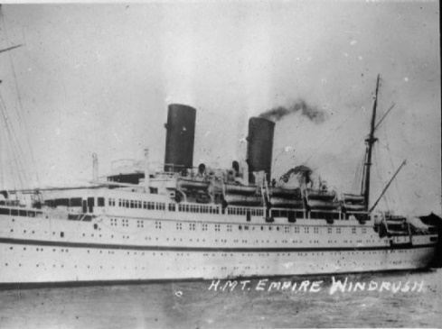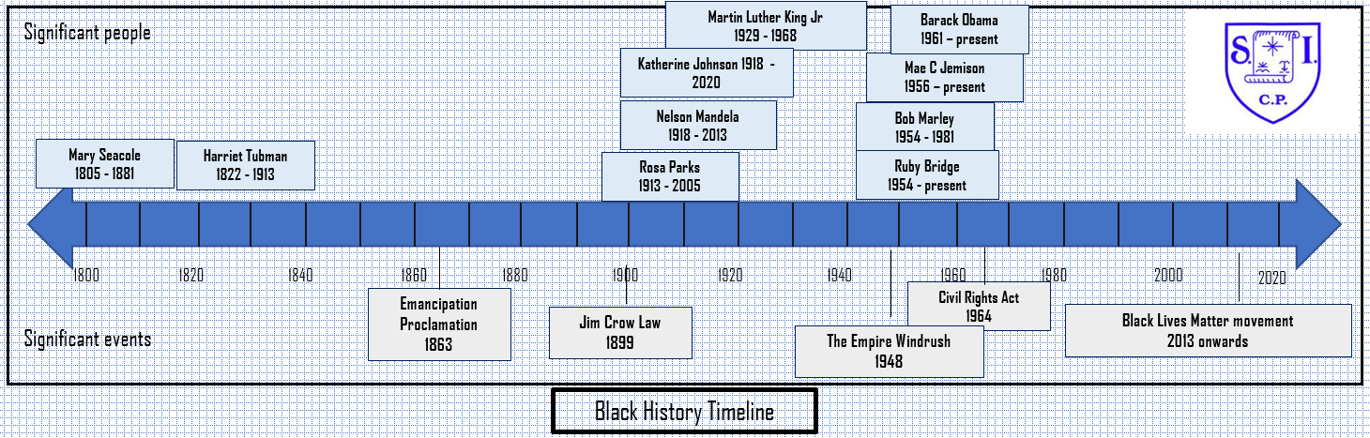

**Key Knowledge I need to understand**

In June 1948 a ship called Empire Windrush docked at a port on the Thames River near London, England. The ship held hundreds of passengers from Commonwealth countries in the Caribbean Sea. They came to England because they knew there were more jobs and opportunities than in their home countries.

Immigrants from the Caribbean who arrived in Britain between 1948 and 1971 are known as the Windrush generation.

The arrival of the Empire Windrush in London is considered an important moment in making Britain a more multicultural country.

1. **How I will show what I have learned?**

I can find out about the now historic journey the HMT Empire Windrush made

I can find out more about the individuals who travelled on the HMT Empire Windrush

I can research and present information on the scandal that happened in 2018.

I can discuss the impacts that the Windrush generation had on Britain at the time and now.

I can focus on how we celebrate Windrush Day

I can celebrate the lives of those affected by the Windrush

**Key vocabulary I need to know**

HMT Empire Windrush

Caribbean

Commonwealth

Discrimination

Employment

Immigration

Passengers

Migrants

Voyage